Brazilian E-Commerce Public Dataset by Olist

- Market Basket Recommendation System Overview
This project focuses on building a Market Basket Recommendation System to enhance user experience by predicting preferences based on past interactions. Recommendation systems, a key part of information filtering, are widely used to personalize products and services in real-world applications. The goal is to design an automated solution that identifies patterns in user behavior and suggests relevant items. This document outlines the high-level technical architecture, covering the complete pipeline from data collection and processing to model selection and deployment, providing a clear view of system components, workflows, and how the final model delivers personalized recommendations to end users. This tutorial is in an IPython Notebook for Kaggle Dataset: https://www.kaggle.com/olistbr/brazilian-ecommerce
- Data Overview
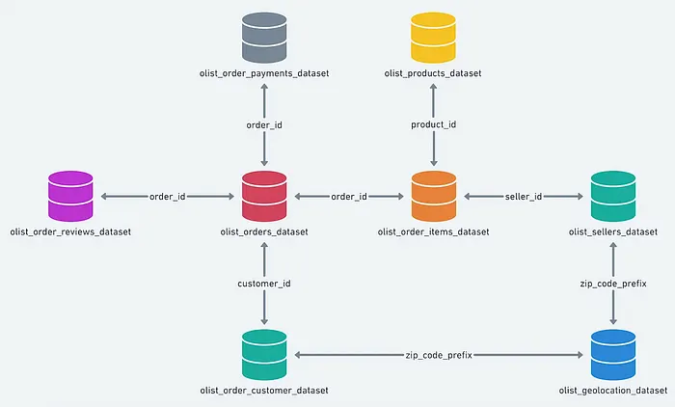
The Olist Store dataset is organized as a relational database with multiple interconnected tables, offering a complete view of e-commerce operations. These relationships can be understood through an Entity-Relationship (ER) diagram. While the dataset is often explored using CSV files and functions like read_csv(), this project uses the assigned database file. The tables collectively capture order details, customer information, products, payments, and logistics, enabling structured and multi-dimensional data analysis.
:

- Data Modeling
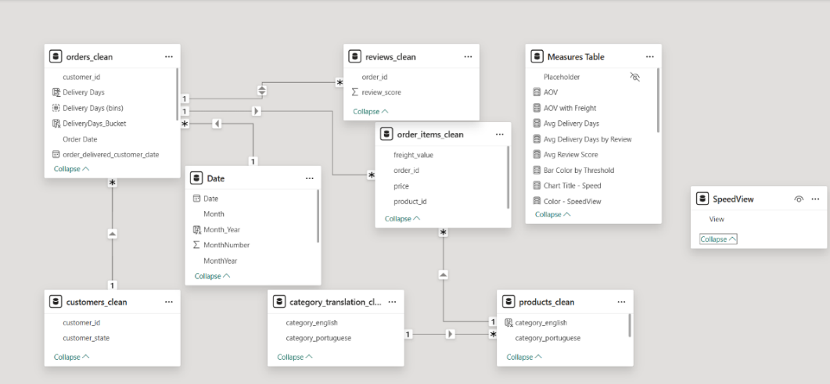

EDA

Exploratory Data Analysis (EDA) is an approach/philosophy for data analysis that employs a variety of techniques (mostly graphical) to.
- Order growth unusual since 11-2017 go with lots of 1 & 2-star reviews.
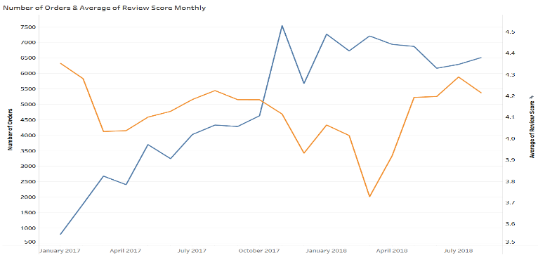

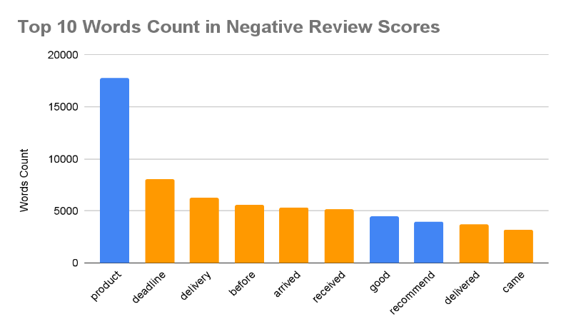
- Slow delivery, not as expected, damaged package → Delivery.

58%

- Delivery Late Rate:
  - There has been a significant change since 10-2017
- The order growth rate increased strongly
- The delivery late rate decreased strongly
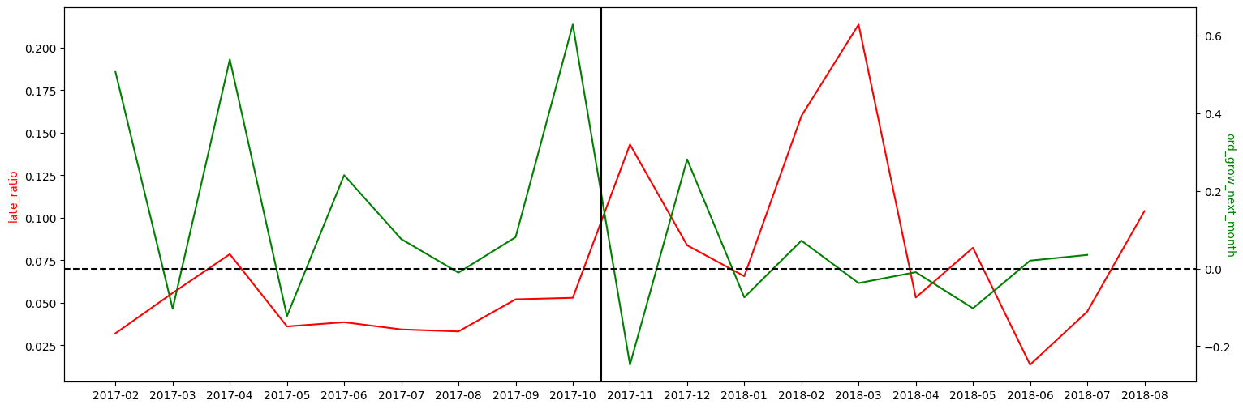
Correlation between Late Delivery Rate & Orders Growth

- Delivery Time:
- Correlation between Delivery Time & Number of Orders in 2017
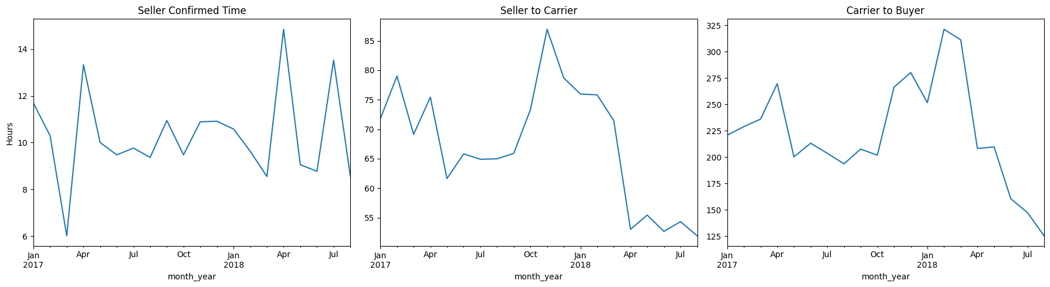
- Delivery speed affect number of sales in eCommerce.
Hypotheses and testing
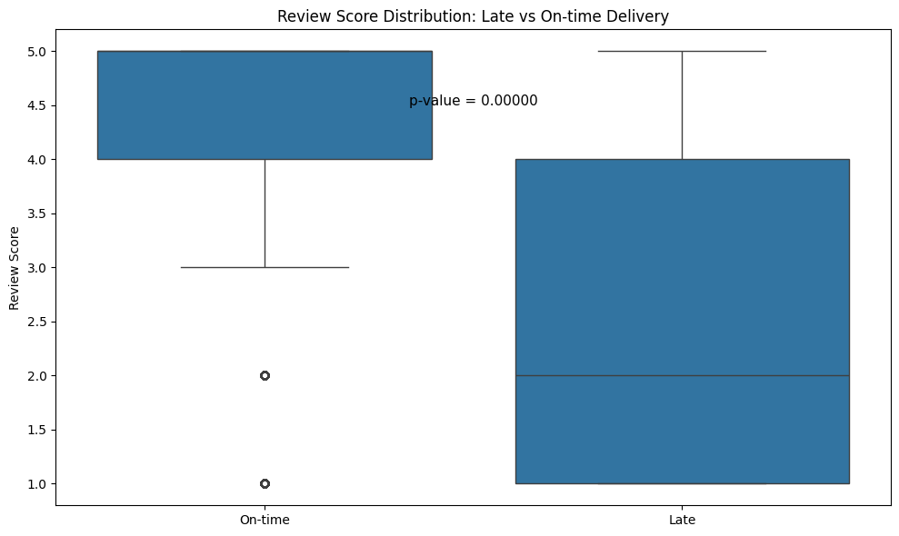
- Late deliveries lead to low review scores

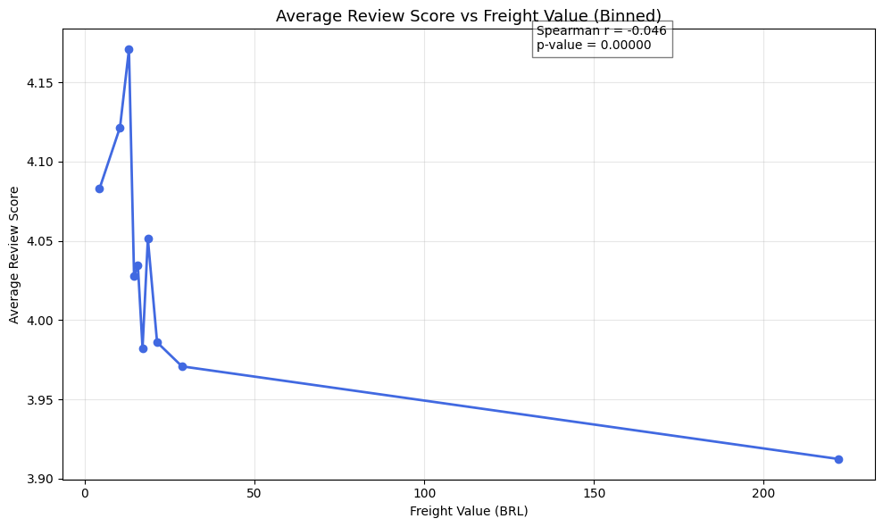
- Higher delivery fee reduces customer satisfaction

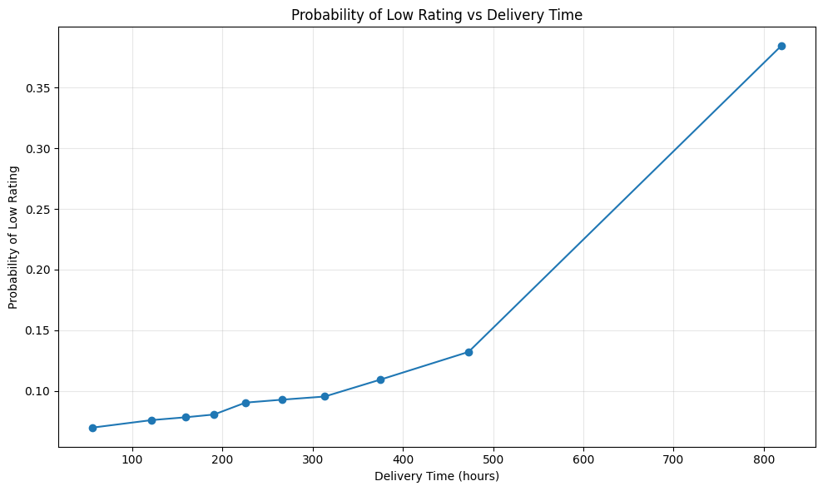
- Longer delivery time increases probability of (1–2) star reviews

Actionable
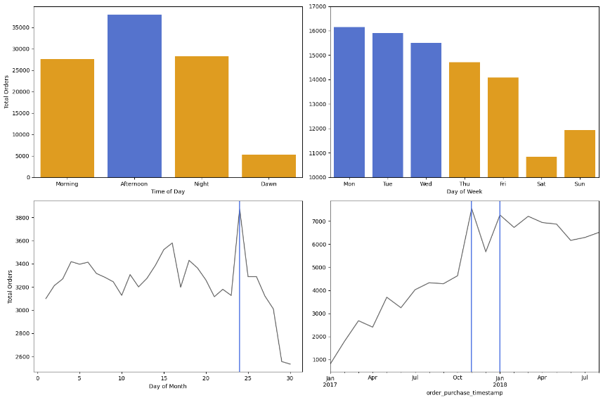
- Improve Delivery Time

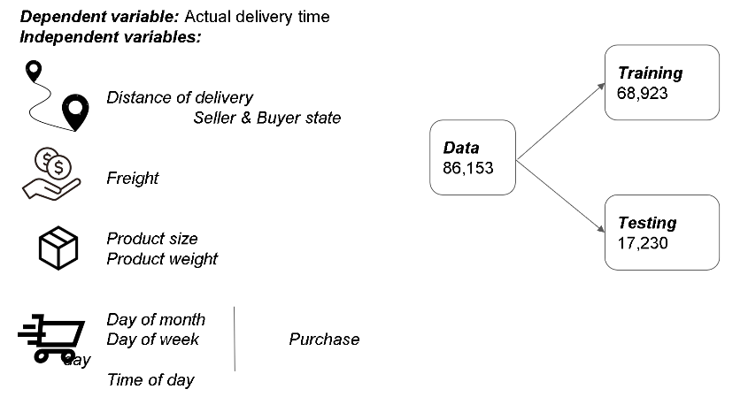
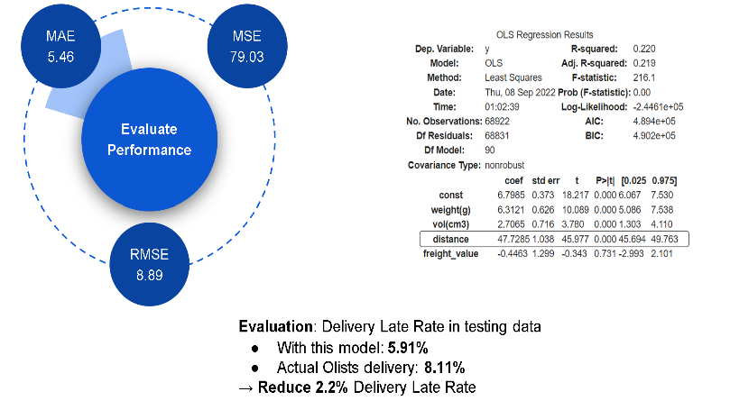
- Predict Delivery Time - Improve Late Delivery Rate
Further exploration
- 46% of Internet users cited free delivery of large orders as the factor that most likely will entice them to use an online grocery service in the future” a survey conducted by PwC (Clarke, 2000)
- “This study aimed to find out how delivery charge and three other situational factors impact upon consumers’ inclination to shop online or in-store for their groceries. Our results show that these four factors all affect the decision whether to shop online for groceries” refer to Huang, Y. and Oppewal, H. (2006), "Why consumers hesitate to shop online: An experimental choice analysis of grocery shopping and the role of delivery fees", International Journal of Retail & Distribution Management, Vol. 34 No. 4/5, pp. 334-353. https://doi.org/10.1108/09590550610660260.
Appendix: Use of Large Language Models (LLMs)
Appendix: Tools and LLM Usage
1. Environment
- Python (Jupyter Notebook)

2. Libraries Used
- Data Processing: pandas, numpy
- Visualization: matplotlib, seaborn
- Statistical Analysis: scipy, statsmodels
- Machine Learning: scikit-learn
- Text Processing: nltk, re, collections
- Geospatial Analysis: folium
- Utilities: datetime, json, os, math
- Data Source: Kaggle API

3. Purpose of LLM Usage
LLMs were used for:
- Debugging and improving code
- Guiding statistical test selection and interpretation
- Enhancing visualizations and code structure
- Assisting in report organization

4. Validation & Ethics
All LLM-assisted outputs were verified using Python and independently interpreted.
LLMs were used strictly as a support tool; all final analysis and conclusions are original.

